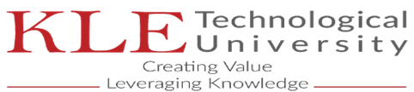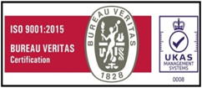

M S S C E T

Date: 25-Jul-2022

**STUDY CERTIFICATE**

This is to certify that, Mr/Miss. **Aditya Desai (USN: 2KL19EC002)**  S/o / D/o **Anil Desai** has studied Bachelor of Engineering (ECE Branch) in our institution from 2019 to 2023 academic years.

The above details are true and correct to the best of my knowledge.

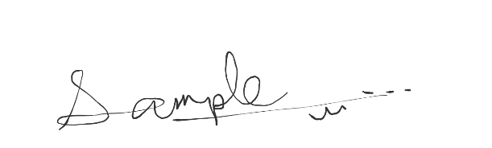

**PRINCIPAL**